*Data and figures from* [*http://rpubs.com/kipp/79069*](http://rpubs.com/kipp/79069)

***Summary of additions to RPub online document:***

* *Table of contents added to report*
* *FDR-controlled collapsed T-test summary statements (section 0.3.1.2)*
* *Collapsed T-test for EBPAS ~ Q9 (section 0.8.1)*
* *Figure of Q9 responses ~ Q28.2 (section 0.8.2)*
* *Figure of Q9 responses ~ Q30.1 (section 0.8.3)*
* *Figure of genomic knowledge on Q28.2c (Section 0.9.2)*
* *Figure of genomic abilitiy on Q28.2v (section 0.9.1)*

1. **Analysis of EBPAS Openness/Divergence sections’ association with question 9:**

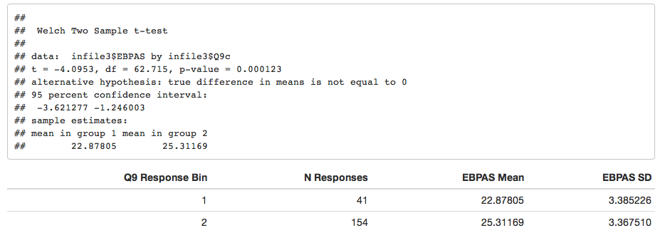

We see that there is a significant difference (P=1.229687510^{-4}) for the combined openness/divergence subsets of EBPAS depending upon how respondents answered question 9.

Those who answered question 9 as “Not at all/To a slight extent/To a moderate extent” have significantly lower scores than those who answered question 9 as “To a great extent/To a very great extent”.

1. **Analysis of Question 9 responses by medical school year grouping (Q28.2)**

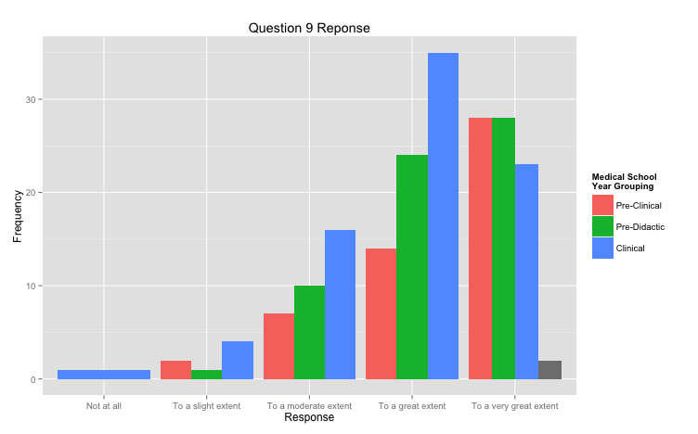

Kruskal-Wallis rank sum test

Kruskal-Wallis chi-squared = 7.9729, df = 2, p-value = 0.02

Comparison of x by group

(Benjamini-Hochberg)

Col Mean-|

Row Mean | 1 2

---------+----------------------

2 | -0.751195

| 0.2263

|

3 | -2.653554 -1.984191

| 0.0119* 0.0354

Q28.2c mean median N

1 1 4.333333 5 51

2 2 4.253968 4 63

3 3 3.949367 4 79

4 NA 5.000000 5 2

There is a significant difference (p=0.02) on the question 9 response by medical school year grouping. Pre-clinical students were significantly more likely to agree with the statement “I think it is important to learn about personalized medicine” than were clinical students. Controlling for FDR, there was not a significant difference between pre-clinical vs. pre-didactic nor pre-didactic vs. clinical.

1. **Analysis of Question 9 responses by interest in research career (Q30.1)**

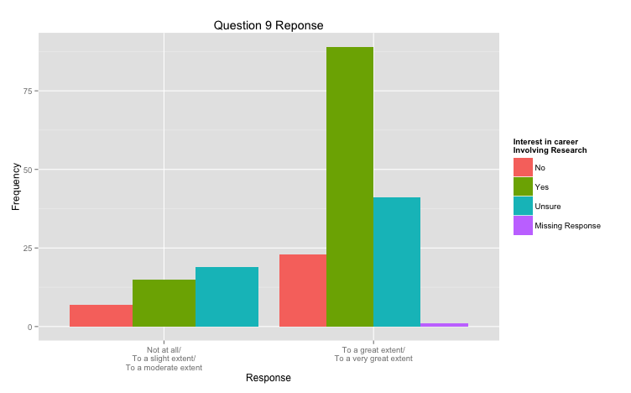

## Kruskal-Wallis rank sum test

##

## data: x and group

## Kruskal-Wallis chi-squared = 11.076, df = 2, p-value = 0

##

##

## Comparison of x by group

## (Benjamini-Hochberg)

## Col Mean-|

## Row Mean | 0 1

## ---------+----------------------

## 1 | 1.837027

## | 0.0497

## |

## 2 | -0.606434 -3.184789

## | 0.2721 0.0022*

## Q30.1 mean median N

## 1 0 3.966667 4 30

## 2 1 4.346154 5 104

## 3 2 3.916667 4 60

## 4 NA 5.000000 5 1

For educational question nine, those who do not want to have a research career (“0”) are significantly different from those who do want a research career, but not significantly different from those who are not sure if they want a research career. Those who do want a research career are significantly different from those who do not want a research career and those who are not sure if they want a research career.

Students who want a research career are significantly more likely to agree with the statement “I think it is important to learn about personalized medicine” than both students who are not sure if they want a research career and students who do not want a research career. Students who do not want a research career are not significantly different in their agreement with this statement than those who do not know if they want a research career.

1. **Analysis of Genomic Comfort (18-21) responses by medical school year (Q28.2c)**

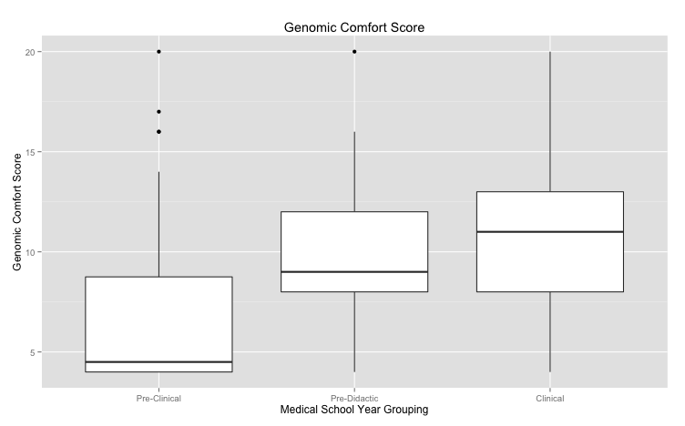

## Q28.2c mean N

## 1 1 9.72549 51

## 2 2 12.79032 63

## 3 3 13.16456 79

## 4 NA 4.50000 2

## Tukey multiple comparisons of means

## 95% family-wise confidence level

##

## Fit: aov(formula = infile3$genomicknowledge ~ as.factor(infile3$Q28.2c))

##

## $`as.factor(infile3$Q28.2c)`

## diff lwr upr p adj

## 2-1 3.0648324 1.444774 4.684891 0.0000401

## 3-1 3.4390668 1.899688 4.978445 0.0000011

## 3-2 0.3742344 -1.079793 1.828262 0.8159236

Pre-didactic students had a significantly lower mean score on questions 18-21 (9.72) than either pre-clinical or clinical students (means=12.79 and 13.16, p<0.00004 and P<0.00001), respectively. There was not a significant difference between the scores for pre-clinical and clinical students.

1. **Analysis of Genomic Comfort (18-21) responses by interest in research career (Q30.1)**

**Not significant; see section 0.5 for this table**

Dual degree was significant; copying output below. We could make a graph for this if we so choose.

**1 = md/phd, 2=md/mph, 3=md/mscr**

**MD/PhDs are significantly more comfortable with this than MD/MPH or MD/MSCR**

## Q29.2 mean N

## 1 1 15.31250 16

## 2 2 11.16667 6

## 3 3 11.22222 9

## 4 NA 11.80982 164

## Tukey multiple comparisons of means

## 95% family-wise confidence level

##

## Fit: aov(formula = infile3$genomicknowledge ~ as.factor(infile3$Q29.2))

##

## $`as.factor(infile3$Q29.2)`

## diff lwr upr p adj

## 2-1 -4.14583333 -7.956727 -0.3349395 0.0308737

## 3-1 -4.09027778 -7.407235 -0.7733205 0.0132944

## 3-2 0.05555556 -4.140100 4.2512116 0.9994084

1. **Analysis of Genomic Ability (22-25) responses by medical school year (28.2c)**

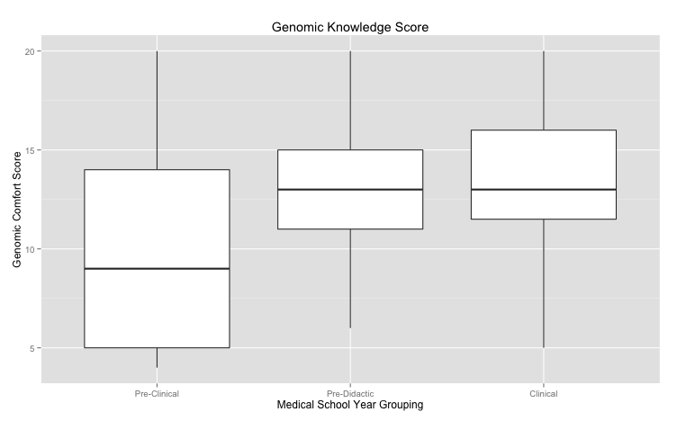.

## Q28.2c mean N

## 1 1 7.020000 51

## 2 2 9.666667 63

## 3 3 10.607595 79

## 4 NA 6.000000 2

## Tukey multiple comparisons of means

## 95% family-wise confidence level

##

## Fit: aov(formula = infile3$genomiccomfort ~ as.factor(infile3$Q28.2c))

##

## $`as.factor(infile3$Q28.2c)`

## diff lwr upr p adj

## 2-1 2.6466667 0.9904112 4.302922 0.0006249

## 3-1 3.5875949 2.0072944 5.167896 0.0000007

## 3-2 0.9409283 -0.5361508 2.418007 0.2909417

Pre-clinical students had significantly lower genomic comfort scores than did either pre-didactic or clinical students (p<0.006 and p<1e5, respectively). There was not a significant difference between pre-didactic or clinical students’ genomic comfort answers.

1. **Analysis of Genomic Ability (22-25) responses by interest in research career (Q30.1)**

Not significant